NAME | Kimaya Teli  Abhishek kumar Kairamkonda  Krishna Somani
ROLL NO | 24102C0079  24102C0085  24102C0067
BRANCH | CMPN
DIV | C
SUBJECT | WDL LAB
FACULTY | Dr. Ravindra Sangle

SOFTWARE ENGINEERING & WEB DEVELOPMENT LAB MANUAL
PROJECT CASE STUDY: LEDGERLY — INVOICE & QUOTATION GENERATOR PWA

Experiment No. 4: Design a Web Page Using CSS (Cascading Style Sheets)

1. Pre-Requisites
• Mastery of CSS3 fundamentals: element, class, ID, pseudo-classes (:hover, :focus, :disabled).
• Deep understanding of Modern Box Model, CSS Custom Properties (Variables), and HSL/Hex color palettes.
• Fluid layout design using CSS Flexbox (1D layouts) and CSS Grid (2D multi-column dashboards).
• Implementation of @media queries for responsive mobile viewports and dedicated @media print styling.

2. Objective
To design and apply a visual styling system for Ledgerly using external CSS (style.css):
1. Define a centralized Design Token Palette (Colors, Surfaces, Borders, Fonts, Elevations).
2. Construct responsive layouts for the Financial Dashboard, Navigation Rail, and Invoice Builder.
3. Provide multi-theme capability: Classic Emerald, Navy Corporate, and Dark Mode.
4. Implement dedicated @media print stylesheets for A4 physical printer paper and PDF export.

3. Theory

3.1 CSS Design Tokens & Variable Architecture
Modern CSS utilizes CSS Custom Properties (:root variables). This decouples presentation values from individual selectors, enabling instant dynamic theme switching, consistent spacing scales, and effortless maintenance.

3.2 Responsive CSS Grid & Media Print
• CSS Grid & Flexbox: Used to position KPI cards (repeat(auto-fit, minmax(240px, 1fr))), alignment of invoice header rows, and table cell formatting.
• @media print: In ordinary screen displays, navigation rails, action buttons, and backdrops are visible. When printing (Ctrl+P) or generating PDFs, @media print hides all non-document UI (.no-print { display: none !important; }) and applies exact A4 page dimensions (210mm x 297mm).

4. CSS Code Implementation Highlights
/* =========================================================
LEDGERLY DESIGN TOKENS & SYSTEM VARIABLES (style.css)
========================================================= */
:root {
--primary: #1b4d4b;
--primary-hover: #143937;
--accent: #2e7d32;
--bg-page: #f4f6f8;
--bg-surface: #ffffff;
--border-color: #e2e8f0;
--text-main: #1e293b;
--text-muted: #64748b;
--shadow-sm: 0 1px 3px rgba(0,0,0,0.08);
--shadow-md: 0 4px 6px -1px rgba(0,0,0,0.1);
--radius-md: 8px;
--radius-lg: 12px;
--font-sans: 'Inter', -apple-system, sans-serif;
--font-serif: 'Fraunces', serif;
}
/* Dashboard KPI Card Grid Layout */
.kpi-grid {
display: grid;
grid-template-columns: repeat(auto-fit, minmax(220px, 1fr));
gap: 1.25rem;
margin-bottom: 2rem;
}
.kpi-card {
background: var(--bg-surface);
border: 1px solid var(--border-color);
border-radius: var(--radius-lg);
padding: 1.5rem;
box-shadow: var(--shadow-sm);
transition: transform 0.2s ease, box-shadow 0.2s ease;
}
.kpi-card:hover {
transform: translateY(-2px);
box-shadow: var(--shadow-md);
}
/* Buttons & Interactive States */
.btn-primary {
background: var(--primary);
color: #ffffff;
font-weight: 600;
padding: 0.65rem 1.25rem;
border-radius: var(--radius-md);
border: none;
cursor: pointer;
display: inline-flex;
align-items: center;
gap: 0.5rem;
transition: background 0.15s ease;
}
.btn-primary:hover {
background: var(--primary-hover);
}
/* Dedicated Print Stylesheet for Lossless A4 Printing */
@media print {
body {
background: #ffffff !important;
padding: 0 !important;
}
.no-print, nav, .app-sidebar, .btn-action, #toast {
display: none !important;
}
.invoice-sheet {
box-shadow: none !important;
border: none !important;
width: 100% !important;
max-width: 100% !important;
padding: 0 !important;
}
}

5. Design System Artifacts

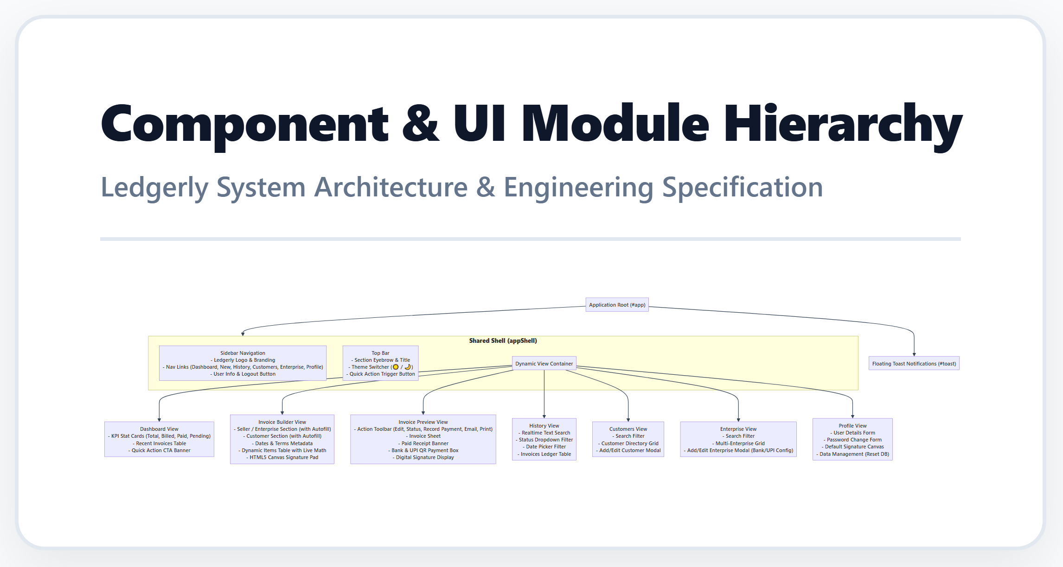
Figure: Component and UI Module Hierarchy Styled via CSS

6. Output / Expected Result
Applying style.css transforms raw HTML views into a responsive web application. The UI presents typographic hierarchy, smooth hover transitions, accessible contrast ratios, and accurate formatting for on-screen inspection and A4 paper output.

7. Conclusion
Experiment 4 demonstrated the practical application of CSS3 custom properties, Flexbox, CSS Grid, and print media queries to build a scalable front-end design system for the Ledgerly web app.

